**Project 3 Written Report**

Team 59

Kathryn Atherton

Ryan Hellyer

Natalie Zimmermann

December 11, 2015

Mr. R. Kent Buchanan

Chief Technology Officer, Harris Corporation

7522 Camelback Dr

Indianapolis, IN 46250

Dear Mr. R. Kent Buchanan:

Thank you for tasking Planes, Trains, and Biological Things with the creation of a robotic model that would allow the transportation of debris to designated recycling locations in areas affected by natural catastrophes. Disasters have severe effects on the surrounding societies; however, Harris Corporation, in collaboration with Eco-Fuels, is looking to reduce this impact by utilizing a Prototype Mover Robot (PMR) to recycle disaster debris into a renewable energy source. The PMR should be able to move about uneven terrain while minimizing damage to the area, follow a line around a closed-loop path, pick up and identify bins containing different materials, and transport them to a drop-off location. In developing a solution to the problem Harris posed, a design team was tasked with creating various prototypes and testing them against pre-defined specifications in order to choose which design would best meet all performance criteria.

Our company developed a PMR powered by two drive motors, which actuate eight legs by the use of four crankshafts. The robot was programmed to follow a painted line on the ground based on the degree of darkness detected by a downward-pointing light sensor. In order to pick up bins, a forklift was attached to a motor at the front of the PMR to raise and lower them. This motor was also used to identify bins by measuring the power required to lift the bin, thereby identifying bin contents based on weight.

Although the final PMR design did not follow a line as effectively as desired and was unable to complete the final demonstration, our company believes that by developing the line following program, making the forklift arm more stable, and developing a more sensitive touch sensor for detecting bins, our PMR design will meet all requirements and be the most ideal design for the task.

Sincerely,

Planes, Trains, and Biological Things

**Executive Summary**

Planes, Trains, and Biological Things was tasked with creating a Prototype Mover Robot (PMR) to transport debris from disaster sites for processing. The Harris Corporation required that the robot be able to move about and over uneven terrain without wheels or treads that could become stuck in debris piles or wear tracks into damaged or fragile landscapes. Additionally, Harris Corporation requested that GPS (Global Positioning System) technology not be used for navigation of the PMR because it would be needlessly complicated to apply for this prototype model and too difficult to reconfigure if the bin sites were relocated. Instead, the PMR should navigate between field sites by following a line of paint on the ground. Finally, Harris Corporation required that the PMR be able to autonomously determine the contents of the bin it has collected, move to the respective drop off location for those contents, and drop off the bin.

Before designing solutions to the requirements, research was conducted to gain inspiration for PMR operation. The design team also brainstormed different ways of accomplishing each of the previously mentioned tasks and gathered them in a morphological chart (See Table 1 in Appendices). These ideas were applied in different prototypes to see how they would interact with each other and to test their compatibility. Each prototype was then tested against the design specifications based on Harris Corporation needs, and evaluated (See Tables 3 - 11, 13 - 14 in Appendices).

The final PMR design has eight legs actuated by four crankshafts and a forklift-style bin grasping mechanism. This walking mechanism was determined to be the most ideal of all the prototypes due to its simplicity, large range of motion, and efficient use of resources. The clearance of the legs was far superior to any other design as it cleared 2 inch obstacles, enabling the PMR to overcome the largest obstacles of any design created and far exceed the target value of 1 inch of clearance.

The forklift mechanism was the most ideal bin-grasping mechanism due to its reliability and ease of integration into the bin-identification operation of the PMR. The forklift was the most likely to pick up the bins of all the designs, due to its positioning on the body of the PMR and the length of the forklift. It does not need to be perfectly accurate in order to be effective in its operation, unlike other designs that were developed, allowing it to pick up 100% of the bins it encounters. This mechanism is able to lift up to 200 grams of mass, which exceeds the technical requirement of 125 grams - the maximum amount of mass the PMR would ever encounter. It is able to determine the contents of the bin by testing predetermined motor powers required to lift their respective bin masses. This mechanism is 87% accurate and takes a maximum of six seconds to complete this task. While this time does not meet the technical requirement specified, the average time to identify a bin is four seconds - one second under the technical requirement. As this mechanism was the only one created which would execute this task, it was decidedly the best solution for this subcomponent of the PMR (See Table 9 in Appendices).

In previous testing by Planes, Trains, and Biological Things, in which all task-specific requirements were measured separately, the final prototype met all criteria, aside from the ability to follow a curved, dotted, or broken line. Unfortunately, during the demonstration, the PMR was required to follow a curved black line, which it failed to follow. Thus, the PMR was unable to reach any of the bins in its path and display its ability in all other sub-functions. Regardless, the robot was able to travel at a speed of 0.241 feet per second, which was 20% under the required speed (0.3 feet per second), with a deviation of 2 inches per foot traveled, meeting the technical requirement of 2.4 inches per foot. On the mini track, specially designed to test the line-following capability of the PMR, the robot was able to overcome the 0.5 inch obstacle effortlessly after the allotted time had expired.

**Design Considerations**

The goal of Planes, Trains, and Biological Things was to create a Prototype Mover Robot (PMR) which would move about and over uneven terrain without wheels or treads, autonomously follow a line about a closed-loop path, pick up and identify bins without human input, and independently transport bins to their designated drop off points based on their contents. In order to determine whether a design was successful, minimum requirements and target design specifications were created that the PMR should meet or exceed. To be deemed successfully mobile, the PMR must move at an average velocity of at least 0.3 feet per second, but ideally at 0.6 feet per second. The PMR should deviate from the ideal path less than one-tenth of the distance traveled, and have a turning radius of less than four inches. To be considered successful at following a line, the PMR must find a line in less than five seconds when deviated from the line. To be deemed successfully mobile, the PMR must be able to travel over obstacles of at least one inch while traveling at a velocity of at least 0.5 feet per second. To be considered successful at bin transportation, the PMR should be ideally able to carry at least 250 grams worth of mass at at least 0.6 feet per second for at least 30 feet, place a bin within three inches of the center of the bin drop-off location such that the entire bin is within the designated location, and disengage from a bin in less than five seconds. To be considered successful at identifying bin contents, the PMR must identify a bin within one second of engaging with it and have 100% accuracy in correctly determining the contents of the bin. In addition to meeting these requirements, Harris Corporation’ specifications barred use of wheels or treads for locomotion, so alternative locomotive designs were required for the PMR.

In order to organize the project, the tasks were divided between all members of the design team in an effort to optimize the skills of each team member. As a result, Ryan Hellyer was tasked to work on the physical robot, Kathryn Atherton was in charge of the programing, and Natalie Zimmermann was responsible for recording the team’s progress (See Figure 1 in Appendices). To confirm that progress was constantly being made, a different deliverable was the focus of each month. At the same time, the final deliverable and the interdependence and compatibility of all deliverables were always considered. In October the main focus was building the robot, and determining its basic structure. In November, the focus shifted to completing code logic and ensuring the robot’s successful performance. Finally, in December, the focus became collecting data, drawing conclusions, and composing the final report (See Figure 2 in Appendices).

Once project responsibilities were distributed among the design team and specifications for success were created, research was done concerning the NXT kit, previous designs for robots without wheels or treads, and nature’s varied solutions for locomotion. Then, assorted methods for each subcomponent of the PMR to complete their tasks were brainstormed and put into a morphological chart (See Table 1 in Appendices). Various prototypes were created using this morphological chart, and a House of Quality was constructed to measure the success of each prototype (See Tables 13 and 14 in Appendices).

The first prototype consisted solely of a walking mechanism, which made use of the ‘elephant’ style of walking, which consisted of horizontal bars, which would move in a circular pattern while retaining their orientation in order to create walking locomotion. At least 2 legs would be used on each side so that one set would be pushing the robot forward while the other would be resetting and moving forward. The legs would alternate pushing and resetting as the robot moved forward. Unfortunately, this design did not function because the horizontal portion of the legs did not retain their horizontal orientation. Instead, the front of the leg rotated in a circular motion while the back of the leg was stationary, which did not effectively move the robot. Additional problems with this design included mechanism being too fragile, using too many resources, moving at the slow rate of 0.238 feet/second, having the unacceptable 1:1 ratio of deviation amount to distance traveled, and being too wide. This prototype received 56.3 points in the House of Quality, meaning that it met 11.6% of the target values that represented a perfect PMR.

The second prototype developed incorporated a new walking mechanism, which was believed to be more appropriate for the PMR, as it would give the PMR more stability and control. It was inspired by spiders, and their use of multiple smaller legs to walk. This prototype also incorporated a bin pick-up and identification mechanism (See Sketch 1 in Appendices). This design consisted of a motor, mounted at the top of the robot, with beams attached to the motor perpendicular to the axis of rotation. Between the beams, a sliding hook apparatus was installed such that the hook could slide towards and away from the motor. Rubber bands were wrapped around the hook apparatus to create resistance against movement of the hook towards the motor. Displacement of the sliding hook, and thus the mass of the bin, was measured with an ultrasonic sensor. This mechanism would function as follows:

1. During movement, the beams and hook would be positioned vertically.
2. After arriving at the bin pick up location, the motor rotates forward 90º, placing the beams and hook parallel to the ground.
3. The PMR moves forward to capture the bin.
4. The motor rotates the beams and hook back to the vertical starting position.
5. Based on the displacement of the hook apparatus, an ultrasonic sensor determines bin mass.

After running performance tests, which included accuracy of bin determination and reliability of bin pickup, it was decided that this design was not ideal. The hook was not wide enough to grab the handle of the bin, and in order to grab it, the robot had to be oriented precisely, otherwise it would miss the bin, did not meet the specification, as it successfully picked up bins less than 10% of the time (See Table 5 in Appendices). Additionally, the weight placed on the hook did not displace the shelf as much as expected (See Tables 6 and 7 in Appendices), making it difficult for the ultrasonic sensor to measure the exact displacement for each type of bin, and therefore distinguish the different bin contents.This prototype received 170 points in the House of Quality, meaning that it met 35.1% of the target values for a perfect PMR. While this was better than the first prototype, it still did not meet the standards set by Harris.

In order to improve the performance of the PMR a third prototype was created. This design kept the walking mechanism, but changed the bin-identification, pickup and drop-off location features. The improved bin pickup and weighing mechanism consisted of one bar connected to each side of a motor, perpendicular to its axis of rotation. Pickup is performed with the bars in a horizontal forward-pointing direction while moving forward. When the bars have passed through the handle of the bin, the motor rotates the bars upward. The PMR was able to recognize when to rotate the bars using a touch sensor, which indicates the presence of a bin (See Sketch 2 in Appendices). Weighing, and therefore bin identification, is performed by determining the motor power required to lift the bin. The lifting motor power starts at 55, which is the minimum power needed to lift the heaviest organic bin, if a touch sensor positioned perpendicular to the forklift is not pressed after 2 seconds of attempting lifting the bin with that power, the motor tries to lift the bin at a power of 65, which corresponds to the minimum power needed to lift the heaviest ceramic bin. If the touch sensor has not been depressed after 2 seconds, the content is metallic and the motor turns at a power of 100 to lift the bin up completely. Thus, the bin type is determined. The bin drop off location mechanism made use of a touch sensor that would hit an object on the ground in the drop off location. Theoretically this model was very good, but it had some flaws when put into practice. In order to execute this correctly, a bin drop-off identifier must cross the created path. However, this type of identifier is not useful on the course, as it blocks the path of the PMR once it has identified the location, thus disqualifying this mechanism from use. Another major problem with this design was that the sensor was not sensitive enough and would only respond to being pushed in a specific way that would be unlikely in the field. An additional flaw of this design determined after testing, (See Table 3 in Appendices) was that this walking mechanism could not overcome taller obstacles, and therefore did not meet the target values set by the company. Many short legs limited the range of motion and did not allow the the PMR to climb over high obstacles. This prototype received 369.9 points in the House of Quality, meaning that it met 76.3% of the standards created by Planes, Trains, and Biological Things. Again, this was the best prototype created thus far; however, it was decided that the walking and drop-off location mechanisms must be changed in order to create an even better overall design.

A fourth and final alternate design was created. The main change was the walking mechanism, with which the PMR is powered on each side by one motor, which is connected to two crankshafts, which each power two legs. Running locomotion simulations on Algodoo, a 2-dimensional physics simulator, demonstrated the efficacy of this new design. (See Images 1-2 in Appendices). This design met the target of overcoming obstacles (over 2 inches), and was fast in comparison to previous designs (0.269 ft/sec). Also, instead of a touch sensor, the bin drop off location recognition mechanism makes use of an ultrasonic sensor to sense a flag (See sketch 3 in Appendices). The ultrasonic sensor checks to see whether the flag marking the location of the drop off site is present. Once the flag is located by the ultrasonic sensor, the robot drops off its bin. Depending on the bin content, this process has to be repeated (two times for ceramic, three times for metallic). The touch sensor from the previous prototype was incorporated into this design so as to determine the presence of a bin in front of the PMR. As the PMR approaches a bin, the forklift arm fits under the handle until the bin depresses the touch sensor. The forklift then lifts the bin and determines the contents.

The final prototype design determined the logic for the coding (See Figure 3 in Appendices). As the flowchart describes, the light sensor inputs data from the line, determining which leg to move forward, depending on if it is on the black or white part of the track. This occurs until the touch sensor is depressed by a bin. At this point, the PMR lifts the forklift arm at varying powers, first with power level 55, then at power level 65, and finally at power level 100. The power level used when the second touch sensor is depressed determines the bin contents, which is then output on the NXT brick. The light sensor then continues to determine how the robot moves until the ultrasonic sensor detects the flags placed at each of the bin drop-off locations. Then, depending on the bin type, as well as the number of flags that the PMR has already passed, the PMR will either set down the bin and continue to follow the line until another bin depresses the touch sensor, or continue through the flag to find the next bin drop-off location. Once a bin has been set down, the process restarts.

**Result and Discussions**

In order to measure how the prototype would meet the requirements of a real-life situation, the PMR was tested on two tracks that incorporated all of the unique features that the prototype would encounter in an area affected by a natural catastrophe: straight and curved solid black lines, dotted lines, damaged lines, obstacles with a height up to ¾ of an inch, and bins with different materials to pick up and transport to the correct drop-off location for recycling.

Prior to the presentation, the final prototype was tested against the specifications to see how it performed (See Tables 15 - 23 in Appendices). Although the design of the walking mechanism caused the robot to deviate side to side slightly, even when following a line, the overall path of the PMR would be straight, as the deviations would counteract each other. Therefore, following a straight black line it had a deviation of about 2.2 inches per foot traveled, meeting the specification. However, the prototype was not able to follow the line along a curved path, and the deviation measurement did not lie within the limits required by the specifications. This was confirmed in the demonstration. The main cause for this extreme deviation is the large step-size of the PMR, which significantly displaces the light sensor perpendicular to the direction of motion with each step. As a result, the light sensor would routinely overshoot the line and fail to recognize that it had overshot. This led the PMR to eventually miss the line with its light sensor, lose the line completely, and travel in a circle until it eventually rediscovered the line.

As seen in Table 8 in the Appendices section, the fourth and final prototype was able to overcome a great variety of obstacles, ranging from 0.5 inches up to 1.75 inches. This was confirmed in the final demonstration, where the PMR overcame obstacles of a height of 0.5 inches while keeping a constant velocity and not deviating from the line more than 2 inches per foot travelled. This performance exceeds all the requirements set by the Harris Corporation and target values set by Trains, Planes, and Biological Things, and is believed to be the most excellent feature of the PMR. This level of clearance is achieved through the use of crankshafts to power 2 legs each. Thus, at any point when the PMR is moving, one leg is going up while the other is pushing down. This allows the PMR to clear obstacles 2 times higher than the distance of the legs from the center of the gear would indicate.

Although the PMR did not have a chance to display its ability of recognizing bin drop-off locations during the final demonstration as it was not able to follow the curved black line, it was able to recognize a drop-off location, as shown in Tables 10 and 14 in the Appendices Section, during previous testing, and met the requirements set by Harris.

In comparison to other bin pick-up mechanisms developed by Planes, Trains, and Biological things, especially the hook pick-up mechanism (See Sketch 1 in Appendices), the final mechanism chosen (forklift), was believed to be the best. In testing, it was determined that the forklift mechanism could lift up to a weight 200 grams, exceeding the maximum bin weight (metallic) of 135 grams, and therefore meeting the minimum requirements set. This was achieved because the forklift consisted of one bar and could not break, and also because the motor power was high enough to lift the heaviest bin.

Finally, a target value was set to have the PMR identify the bins properly 100% of the time. This could be achieved by differentiating the bins by weight. The PMR should be able to identify bins with a weight of 55 to 75 grams as ‘Organic’, bins with a weight from 85 to 105 grams as ‘Ceramic’, and bins with a weight between 115 grams and 135 grams as ‘Metallic’. The PMR successfully identified the bin content 87% of the time. This was achieved by using the power needed to lift each weight. These exceptionally high reliability values were obtained because the mechanism was simple and robust. The minimum power level was measured to lift the maximum weight of each type, thus heavier bins (and therefore different types of contents) could not be lifted and then misidentified.

**Conclusion and Recommendations**

In conclusion, the PMR created did not perform to its fullest potential, as imagined by Planes, Trains, and Biological Things. The line following program and walking mechanism failed to allow the PMR to execute the desired tasks as expected. While the walking mechanism enables the PMR to clear obstacles as tall as 2 inches and retain a relatively fast speed of 0.27 feet per second at all times, it interferes with the line following program, causing the light sensor to continually overshoot the line due to its large step size.

Other factors that affected the performance of the PMR in testing included the grasping mechanism simplicity and stability, the reliability of the ultrasonic sensor, as well as the touch sensor’s sensitivity. While the grasping mechanism is able to simply and effectively identify bins, it is prone to being knocked out of position during locomotion due to the jerking motion caused by the walking mechanism. Finally, the ultrasonic sensor allows reliable identification of the drop-off locations. However, the touch sensor for determining the presence of a bin requires too much force to recognize bins at all times, especially light organic bins.

To improve on the design of the PMR, Planes, Trains, and Biological Things recommends to redesign the walking mechanism to make the step size smaller. This would improve the quality of the line following program, preventing the PMR from overshooting the line during every step.

Another recommended development of the PMR design is to improve the stability of the forklift arm, which jostles during locomotion, and thus may push bins out of the way, rather than engaging with the bin handle and allowing the bin to depress the touch sensor. Also, the touch sensor that recognizes bins should be developed so that it is more sensitive. Currently, it is not depressed by lighter organic bins, and is instead pushed out of the way. Making it more sensitive would allow the PMR to recognize a larger range of bin weights.

Finally, it is recommended that the design be developed to be lighter, as the motors were not always strong enough to reliably move the PMR forward.

Overall, in theory, the company designed a prototype that would successfully operate in disaster areas and perform all desired tasks, as specified by the Harris Corporation. However, in practice the PMR was unable to perform all of the required tasks, due to its failure to follow a line. The company believes that with the recommended design changes and developments, the next PMR will be able to perform to the standard expected by the Harris Corporation.

**Appendices**

**Figure 1: Workload Distribution** 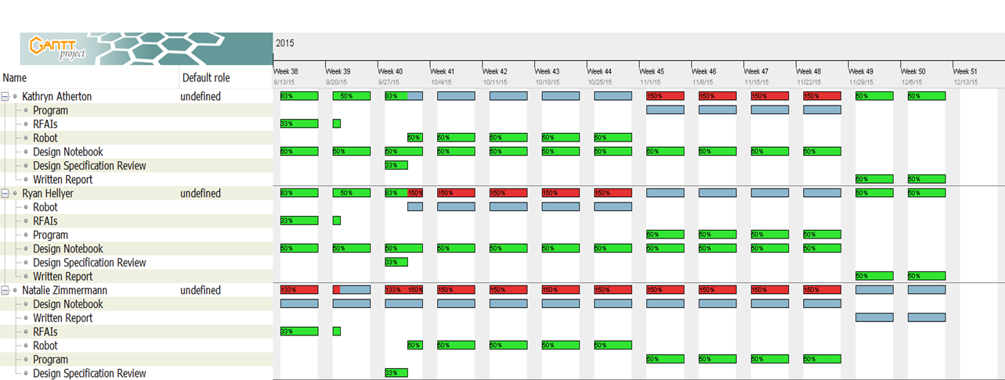

**Figure 2: Gantt Chart**

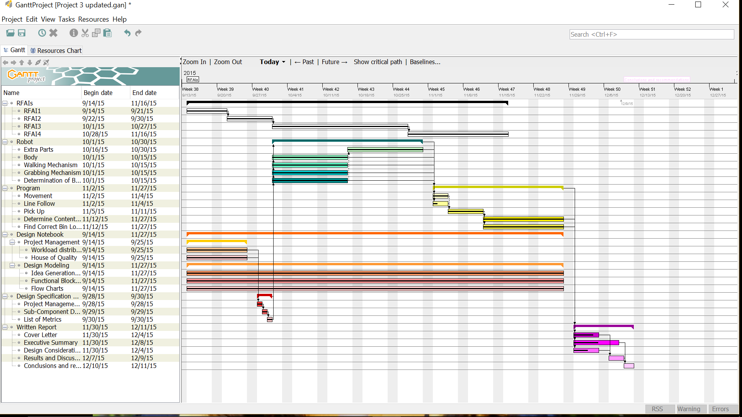

**Figure 3: Flowchart of Code Logic**

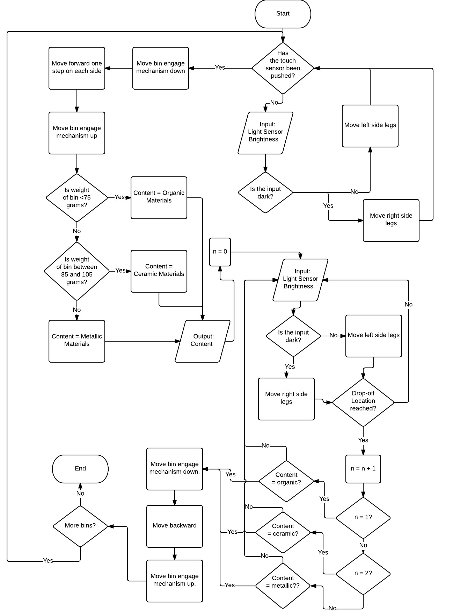

**Sketch 1: Hook Mechanism**

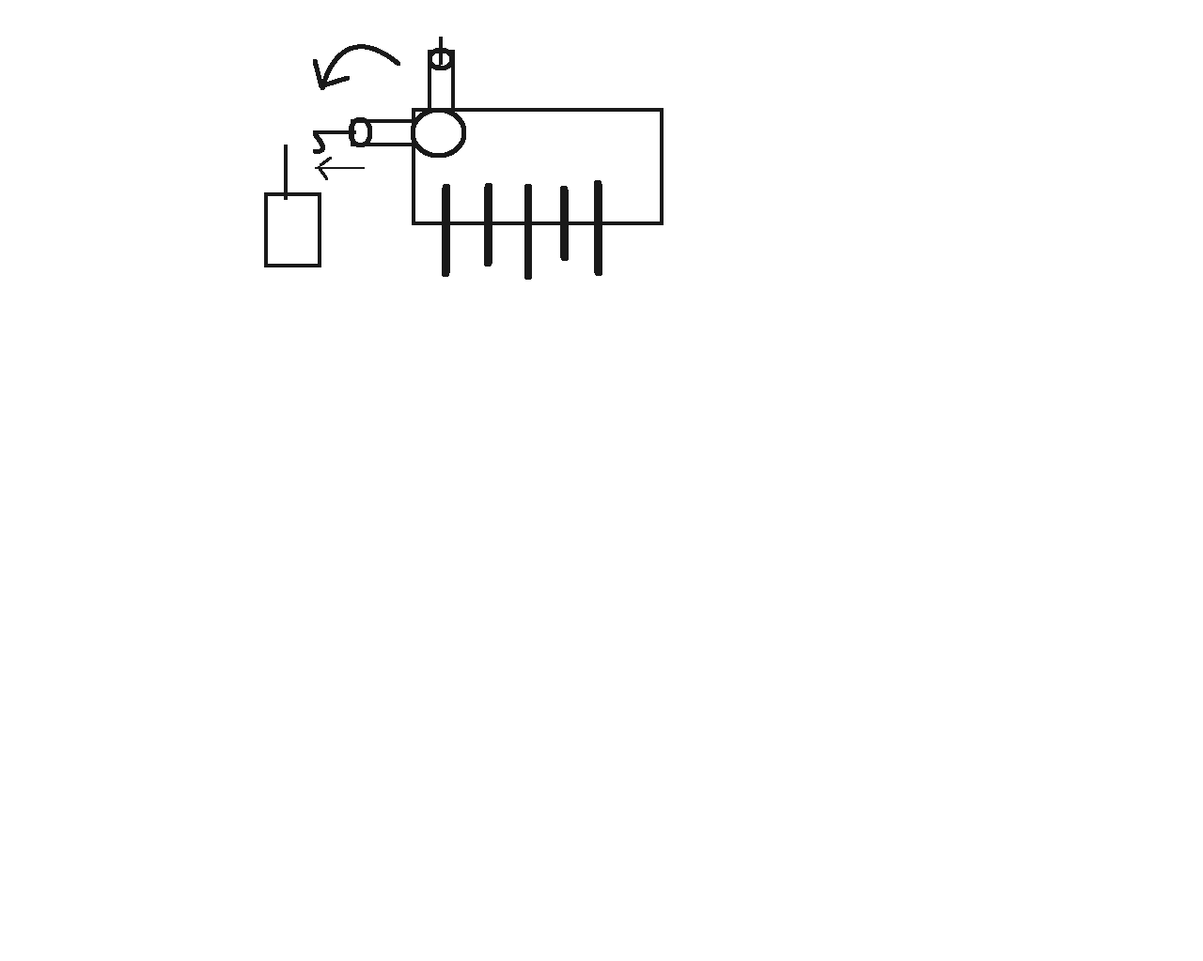

**Sketch 2: Pick Up With Forklift and Touch Sensor**

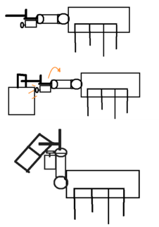

**Sketch 3: Drop-Off Identification with ultrasonic sensor**

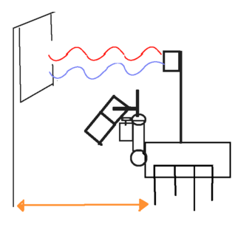

**Image 1: Flat Ground Simulation**

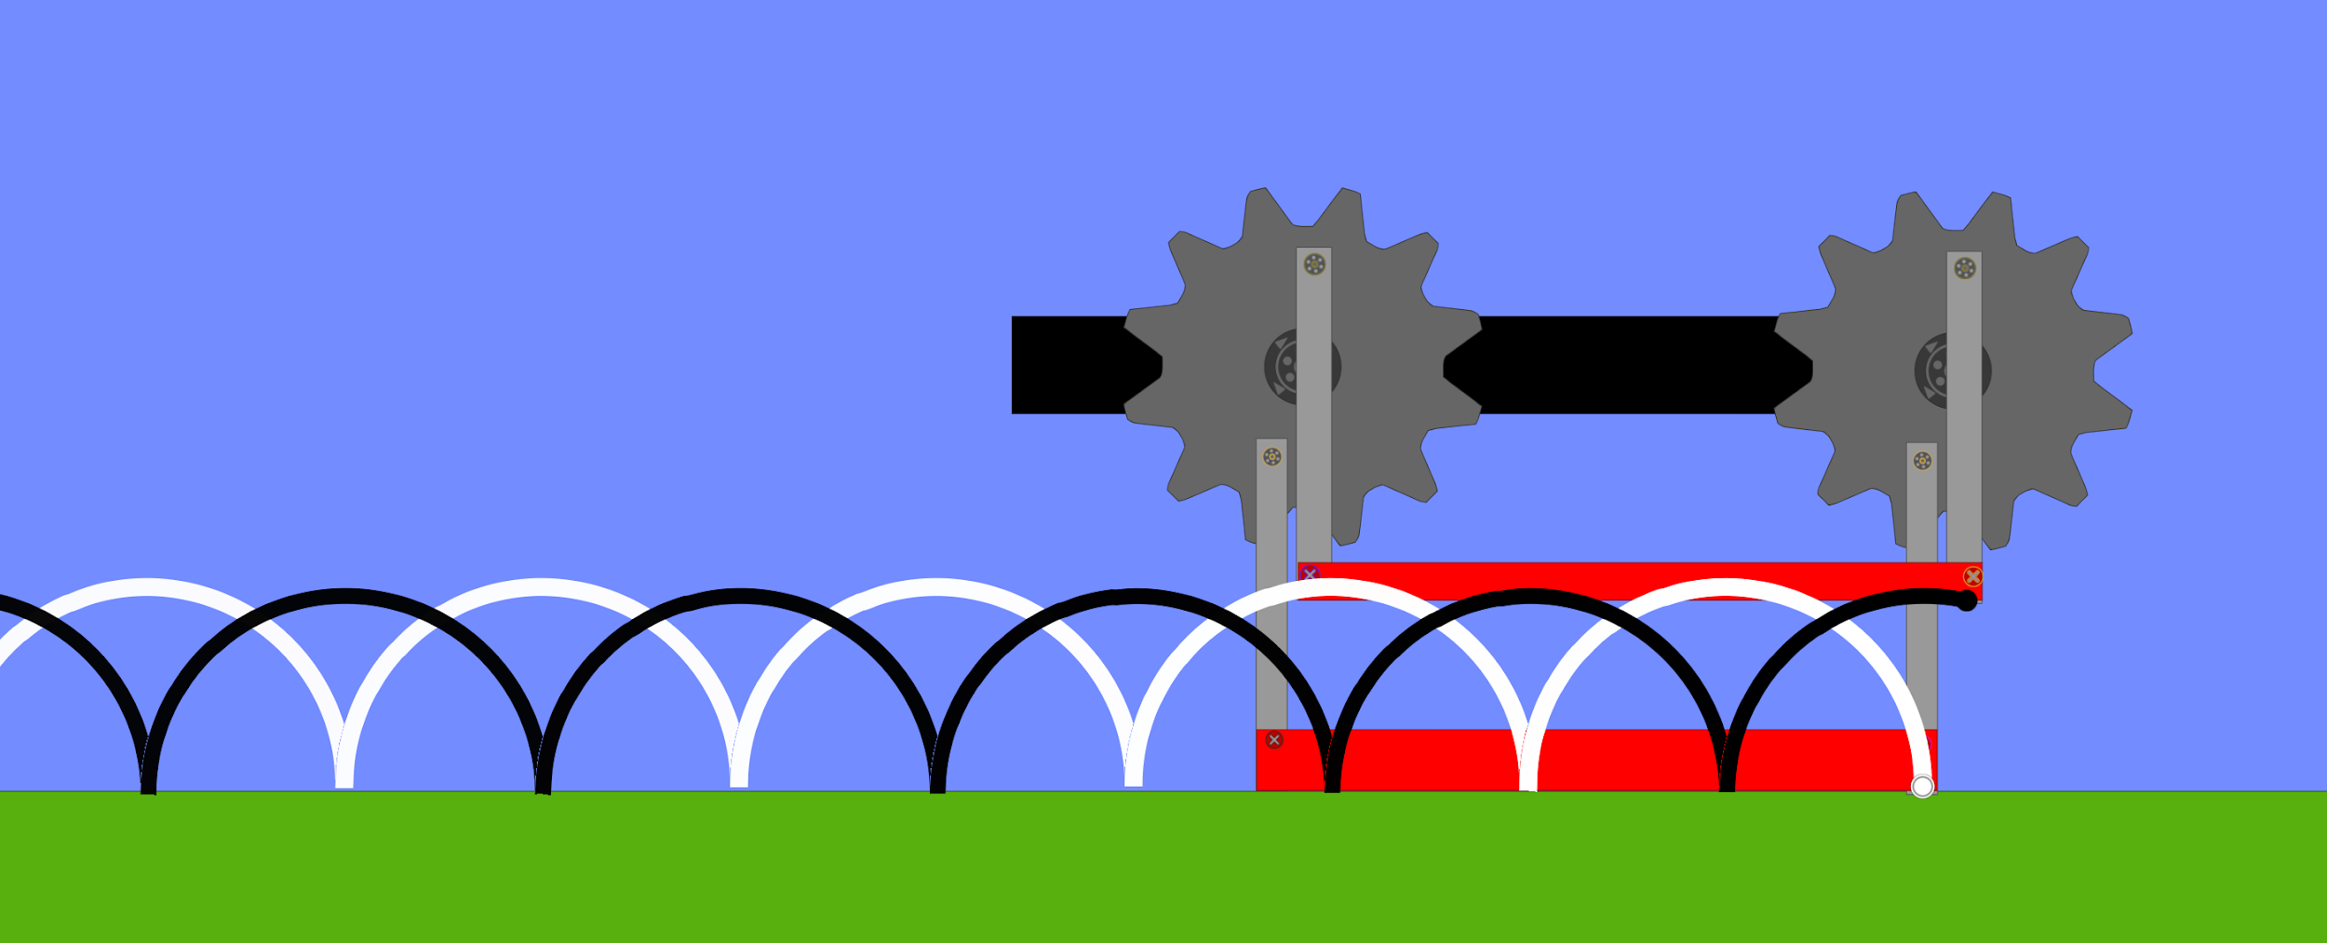

**Image 2.1: Obstacle Clearance Simulation**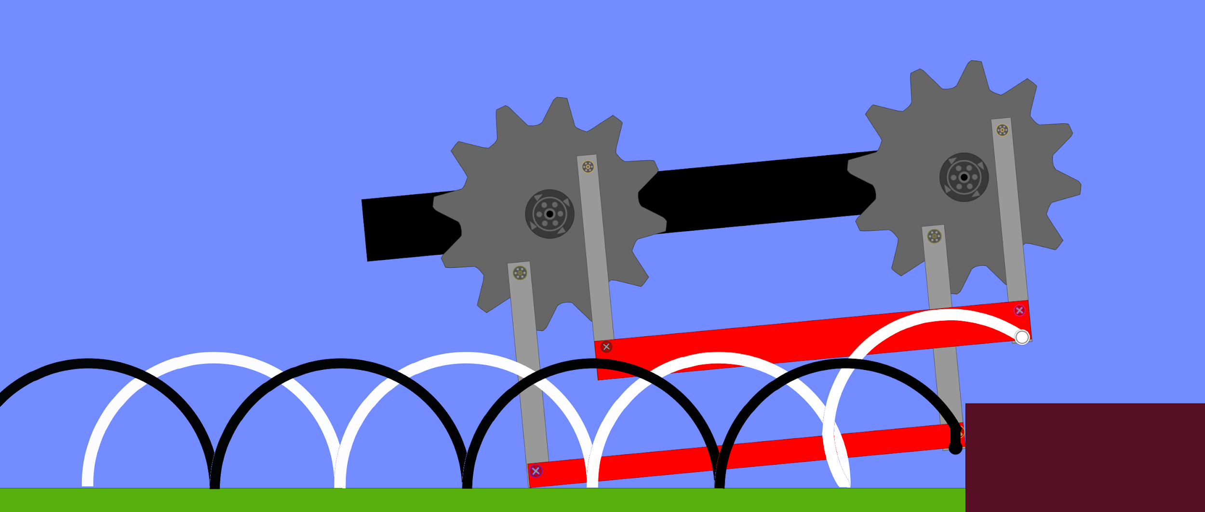

**Image 2.2: Object Clearance Simulation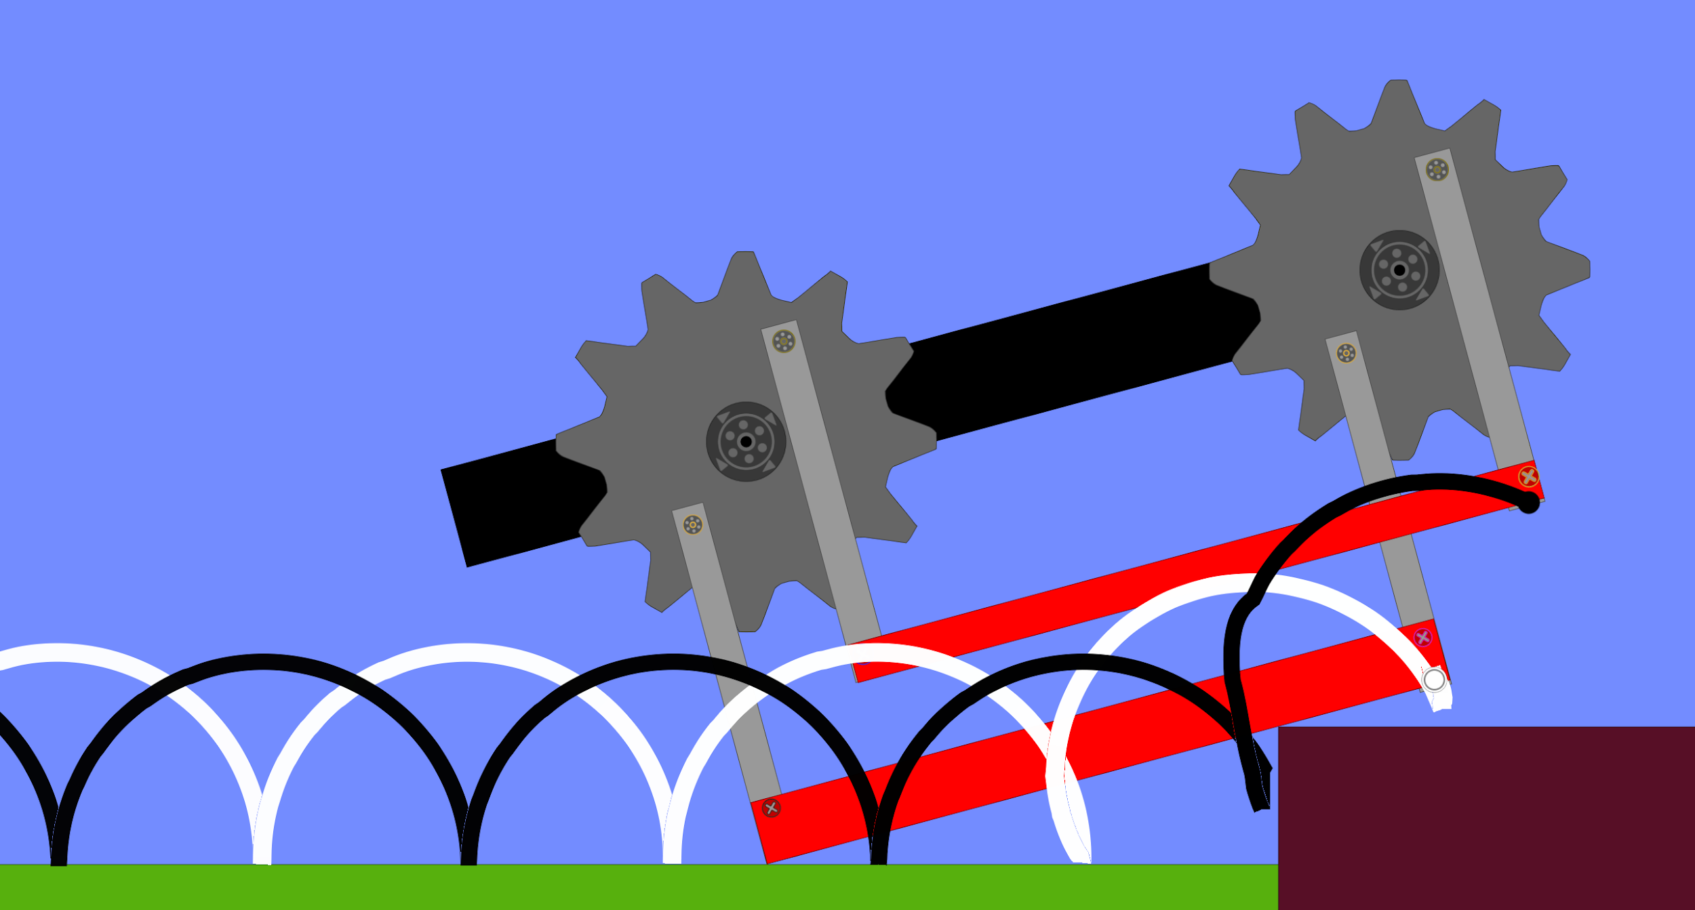Image 2.3: Object Clearance Simulation**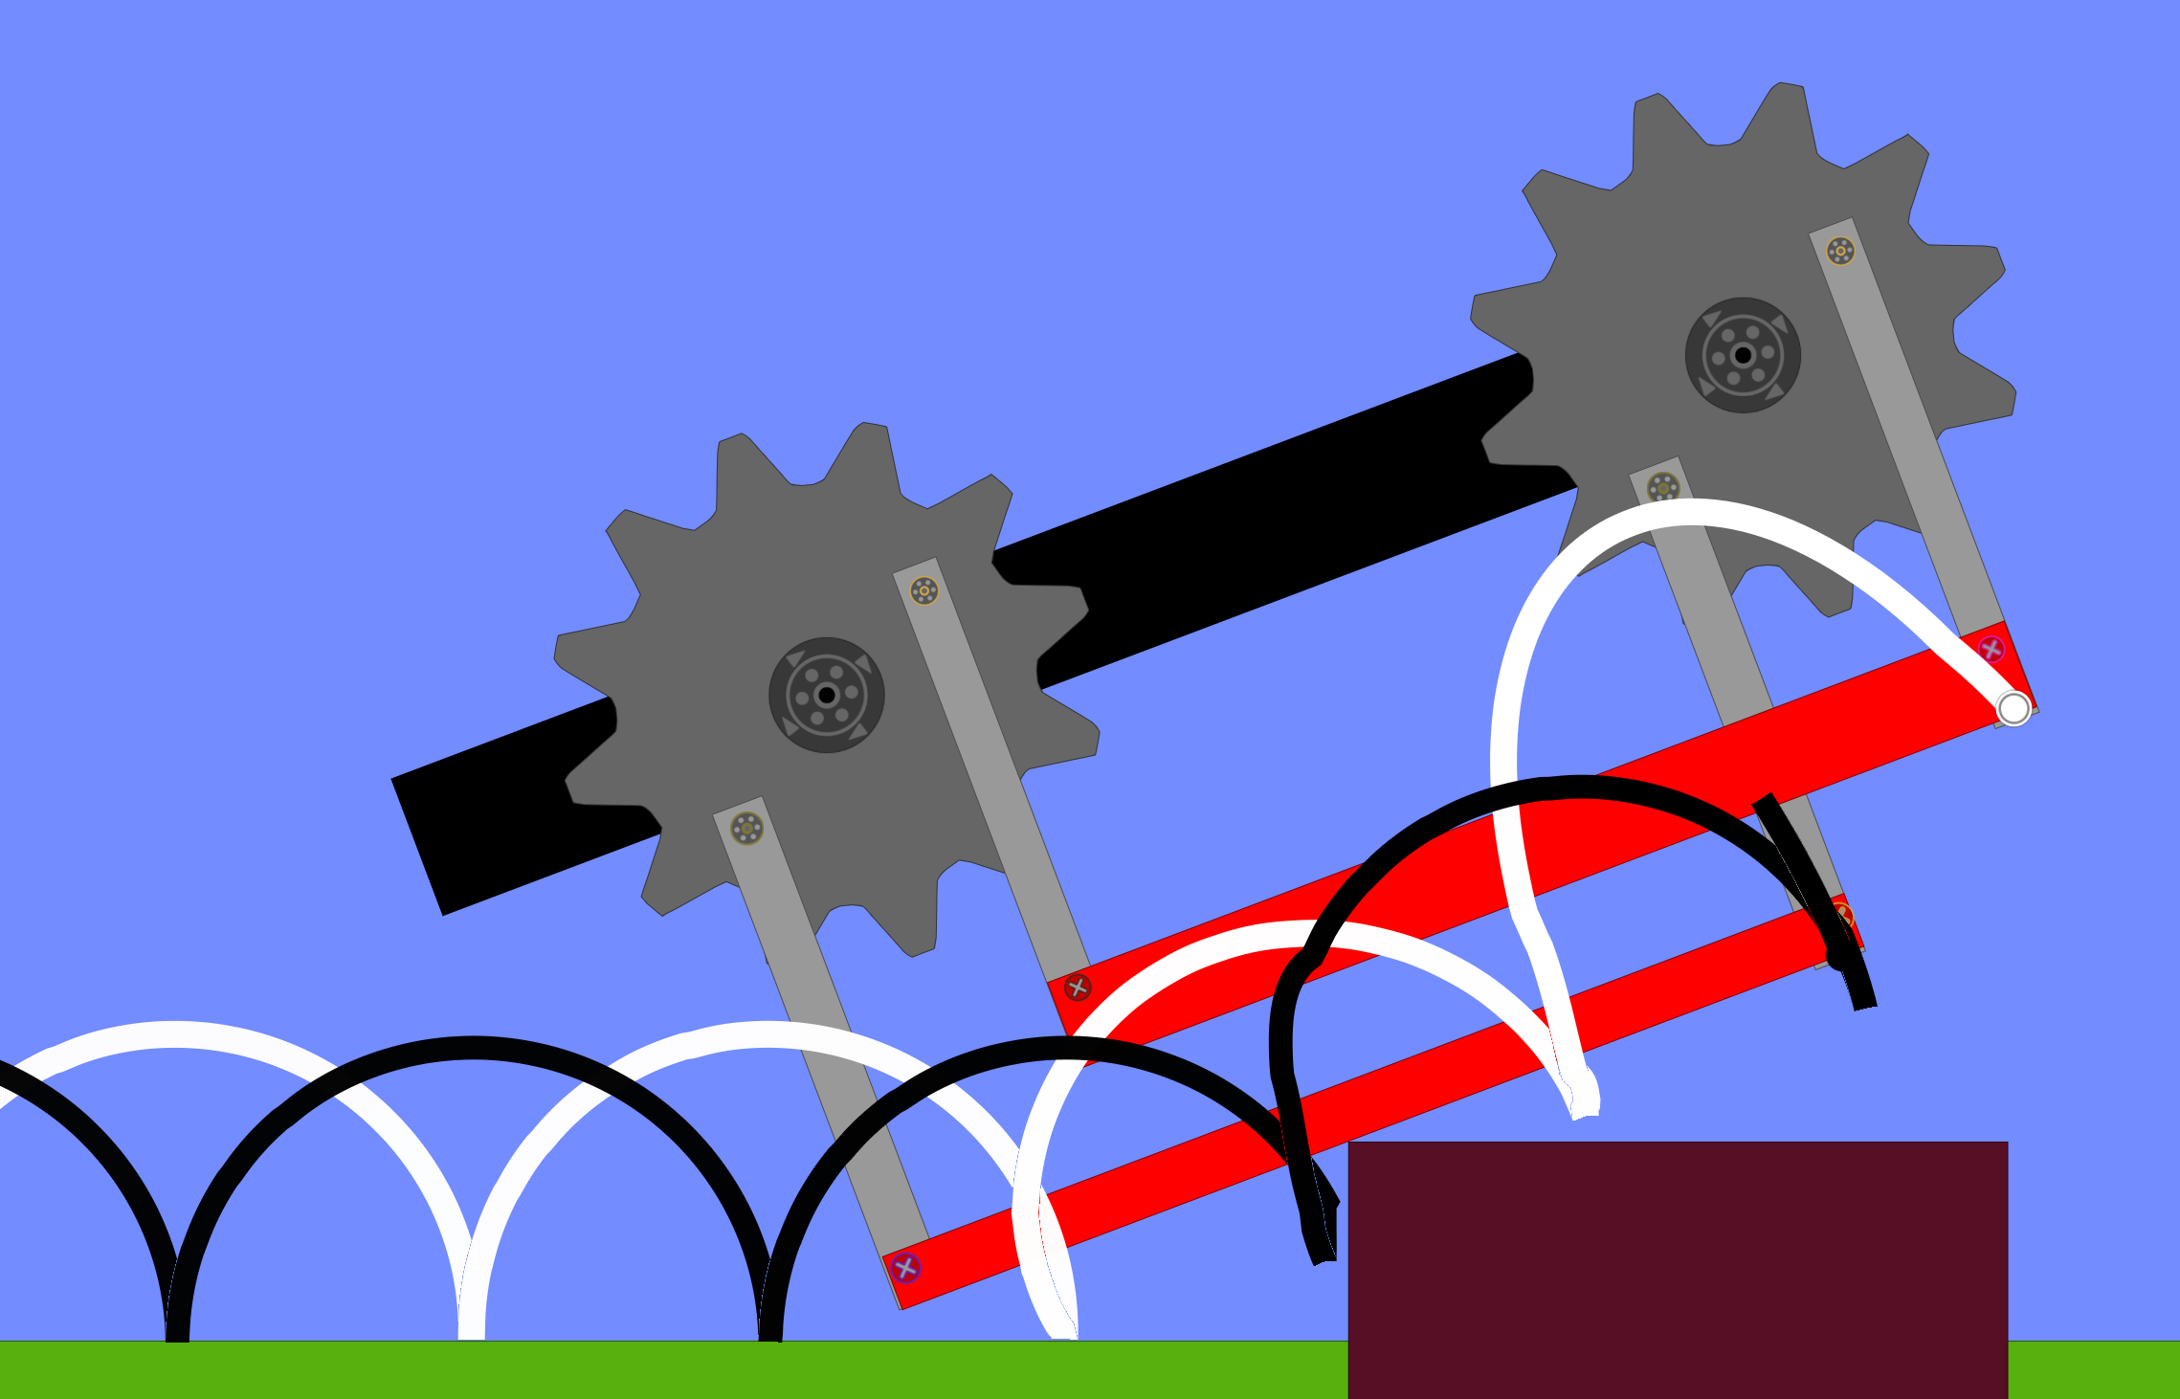

**Image 2.4: Object Clearance Simulation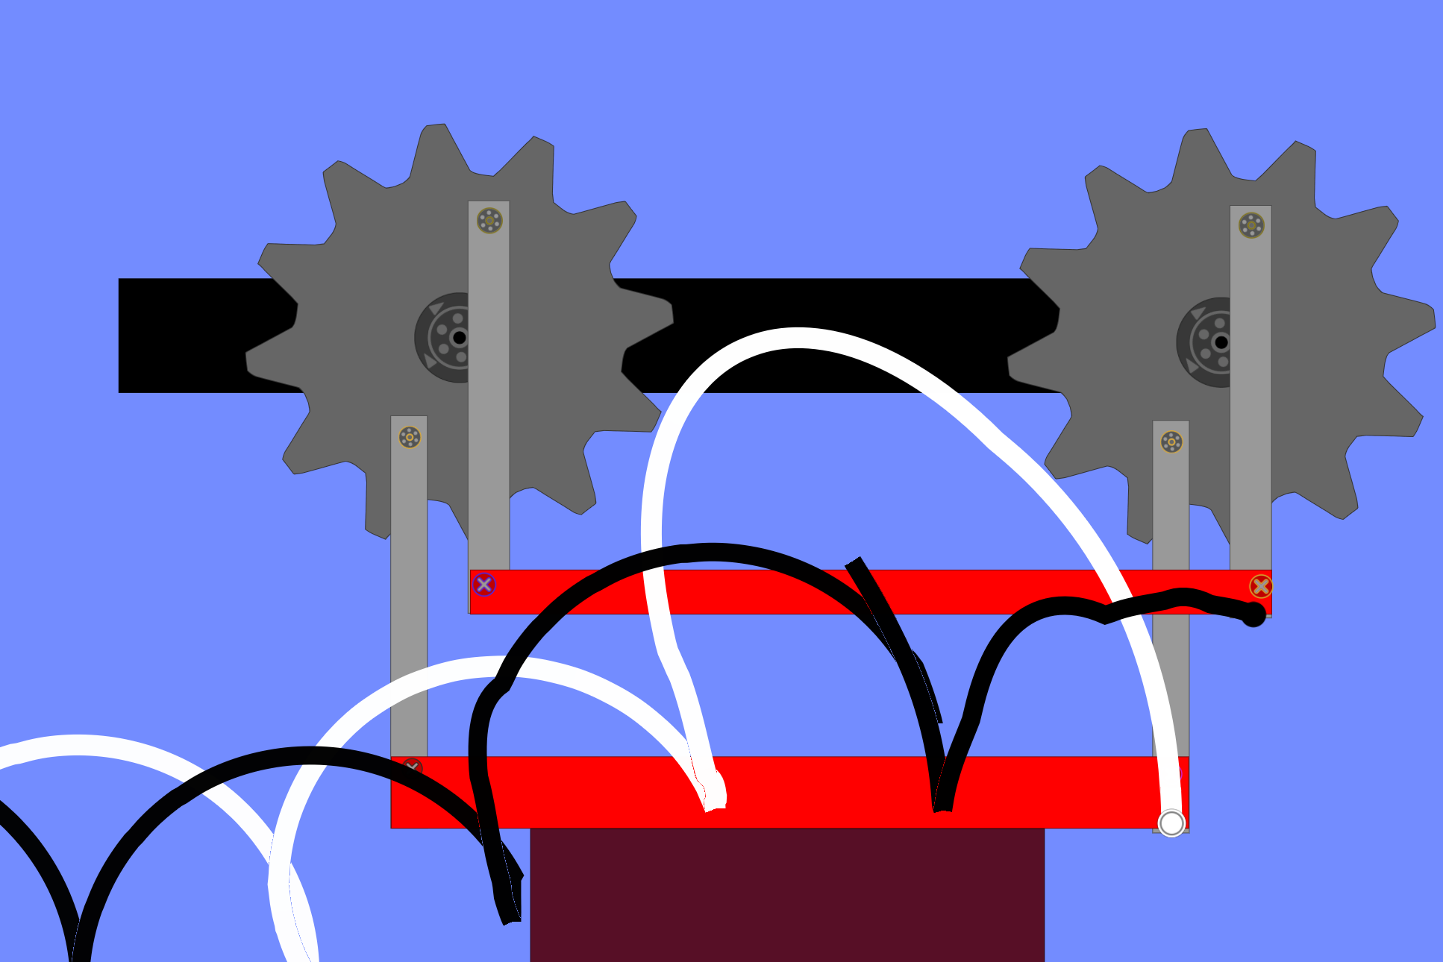Image 2.5: Object Clearance Simulation**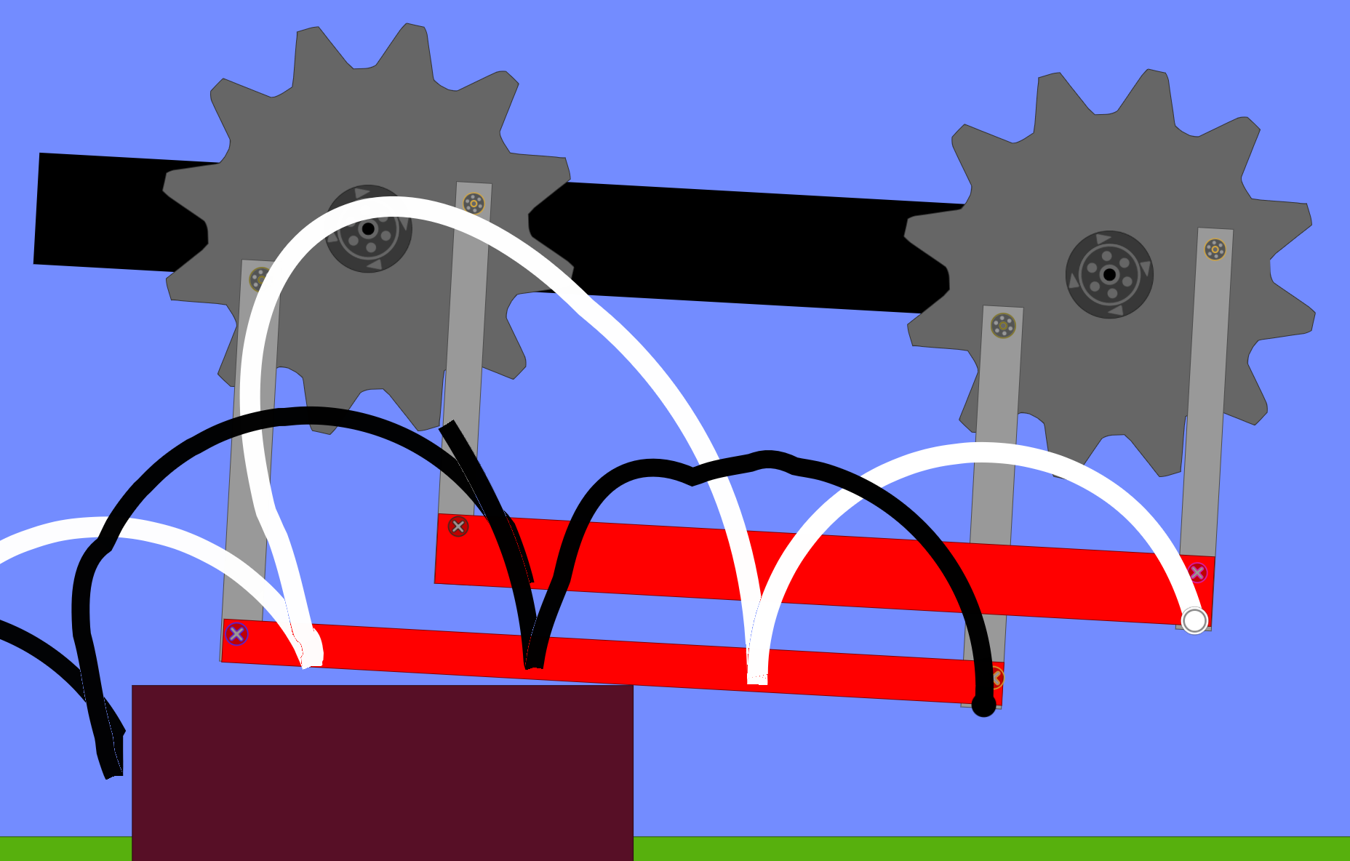

**Image 2.6: Object Clearance Simulation**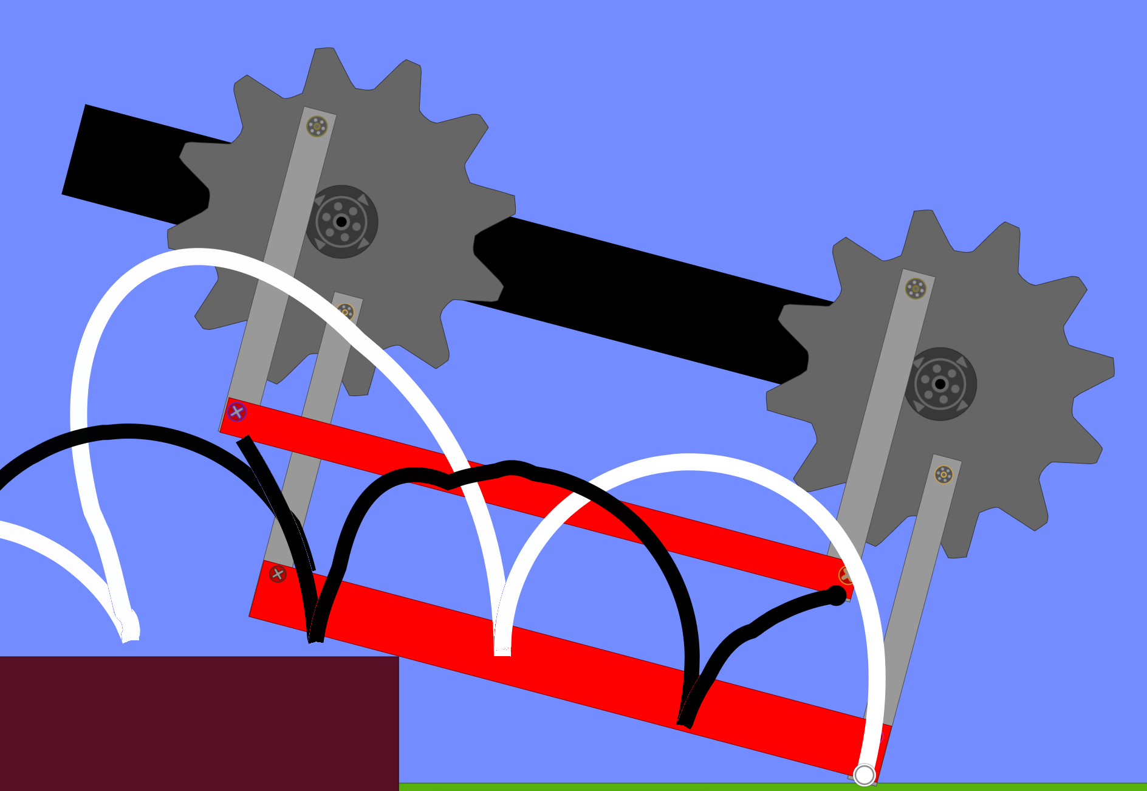

**Image 2.7: Object Clearance Simulation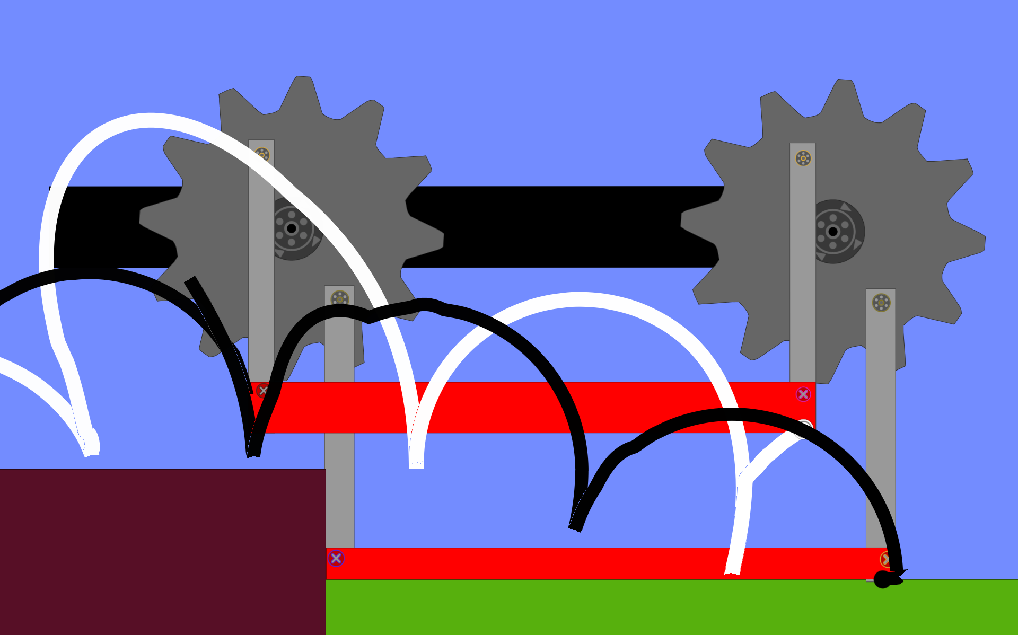Image 2.8: Object Clearance Simulation**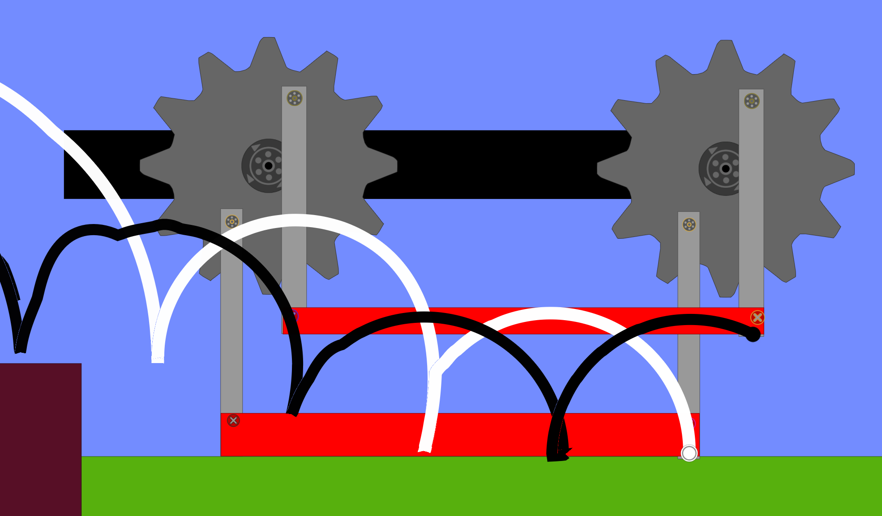

**Table 1: Morphological Chart**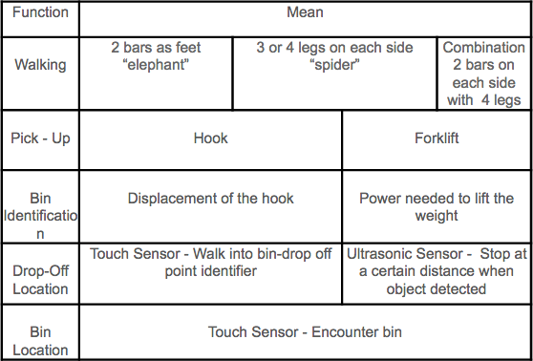

**Table 3: Overcoming Obstacles Testing with Prototype with “Spider Legs”**

|  |  |  |  |  |
| --- | --- | --- | --- | --- |
| **Passed/Failed** | **Obstacle Height** | **Obstacle Shape** | **Time Needed** | **Observations** |
| PASSED | 0.3 inches | Flat | 17 seconds | Deviation |
| PASSED | 0.5 inches | Flat (straight face) | 35 seconds | 90º Deviation, and rubber feet get stuck |
| FAILED | 0.5 inches | Flat with (ledge at the fron) | 25 seconds | Front-right leg popped out |
| PASSED | 0.2 inch diameter | Round | 13 seconds | Deviated to the left |
| PASSED | 0.4 inch diameter | Round | 15 seconds | - |
| FAILED | 0.4 inches | Flat with rounded edges | 20 seconds | 2 leg gets stuck and the first leg slips on the round edge |
| FAILED | 0.8 inches diameter | Round | 10 seconds | Second front-left leg gets cannot overcome obstacle |

**Table 5: Pick-up mechanism/code testing with hook**

|  |  |  |
| --- | --- | --- |
| **Bin pick up** | **Distance** | **Observations** |
| No | 3 inches | Deviation to the left, stops after the bin |
| No | 3.5 inches | Deviation to the right, stops at the line of the bin |
| No | 3.5 inches | No deviation, too far away from bin |
| No | 3.2 inches | Great deviation to the right |

**Table 6: Red rubber band performance for displacement**

|  |  |
| --- | --- |
| **Weight** | **Displacement** |
| 125 grams | 0.5 inches |
| 100 grams | 0.25 inches |
| 75 grams | 0.1 inches |

**Table 7: Yellow rubber band performance for displacement**

|  |  |
| --- | --- |
| **Weight** | **Displacement** |
| 125 grams | 1.2 inches |
| 100 grams | 1.2 inches |
| 75 grams | 1.1 inches |

**Table 8: Obstacle traversal with last prototype (“elephant” and “spider” combined)**

|  |  |  |
| --- | --- | --- |
| Obstacle Height | Completion? | Observation |
| 0.75 inches | Yes | No abnormal performance |
| 1 inch | Yes | No abnormal performance |
| 1.75 inches | Yes | No abnormal performance |

**Table 9: Specification Evaluation for Bin Identification**

|  |  |  |
| --- | --- | --- |
| Specification / Design | Power | Hooke’s Law |
| Robot must be able to identify the bin containing the organic materials, knowing that the bin will have a mass of 55-75 grams. | Yes | No |
| When the robot outputs ‘ceramic materials’, the weight output is between 80 and 110 grams. | Yes | No |
| When the robot outputs ‘metallic materials’, the weight output is between 110 and 140 grams. | Yes | No |

**Table 10: Specification Evaluation for bin drop-off location**

|  |  |  |
| --- | --- | --- |
| Specification / Design | Touch Sensor | Ultrasonic Sensor |
| Distance between the center of the robot at its stop and the center of the bin drop off circle < 6 inches. | No | Yes |
| The time between the robot’s stop at the drop-off point and first identification beep must be less than 3 seconds. | Yes | Yes |

**Table 11: Bin Content Identification**

|  |  |  |
| --- | --- | --- |
| Specification / Design | Power | Hooke’s Law |
| Robot must be able to identify the bin containing the organic materials, knowing that the bin will have a mass of 55-75 grams. | Yes | No |
| When the robot outputs ‘ceramic materials’, the weight output is between 80 and 110 grams. | Yes | No |
| When the robot outputs ‘metallic materials’, the weight output is between 110 and 140 grams. | Yes | No |

**Table 12: Final designs chosen**

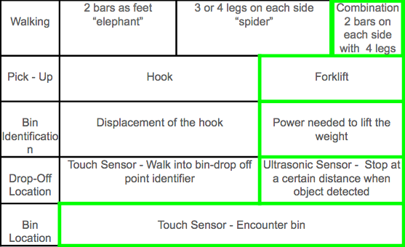

**Table 13: House of Quality**

**Table 14: House of Quality Continued**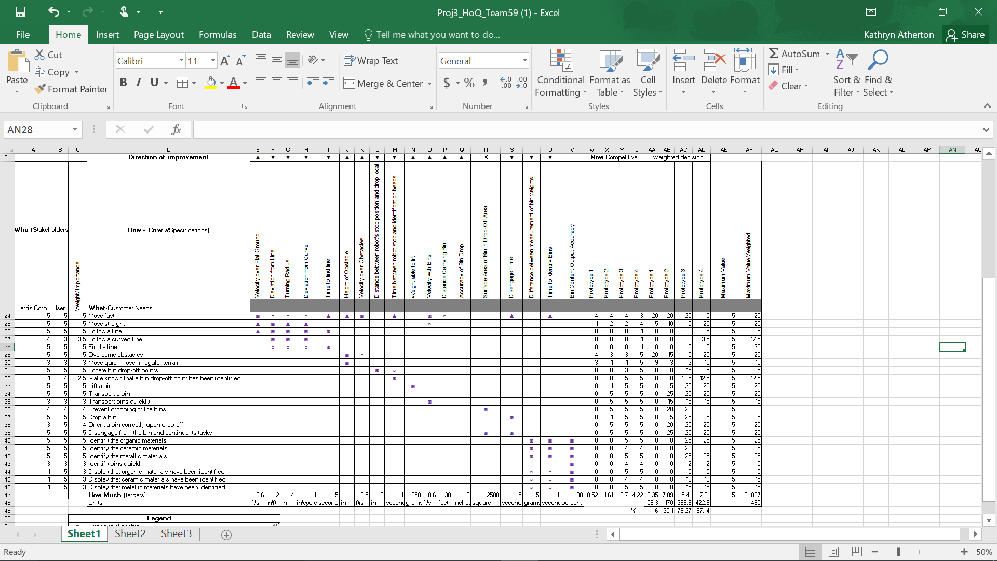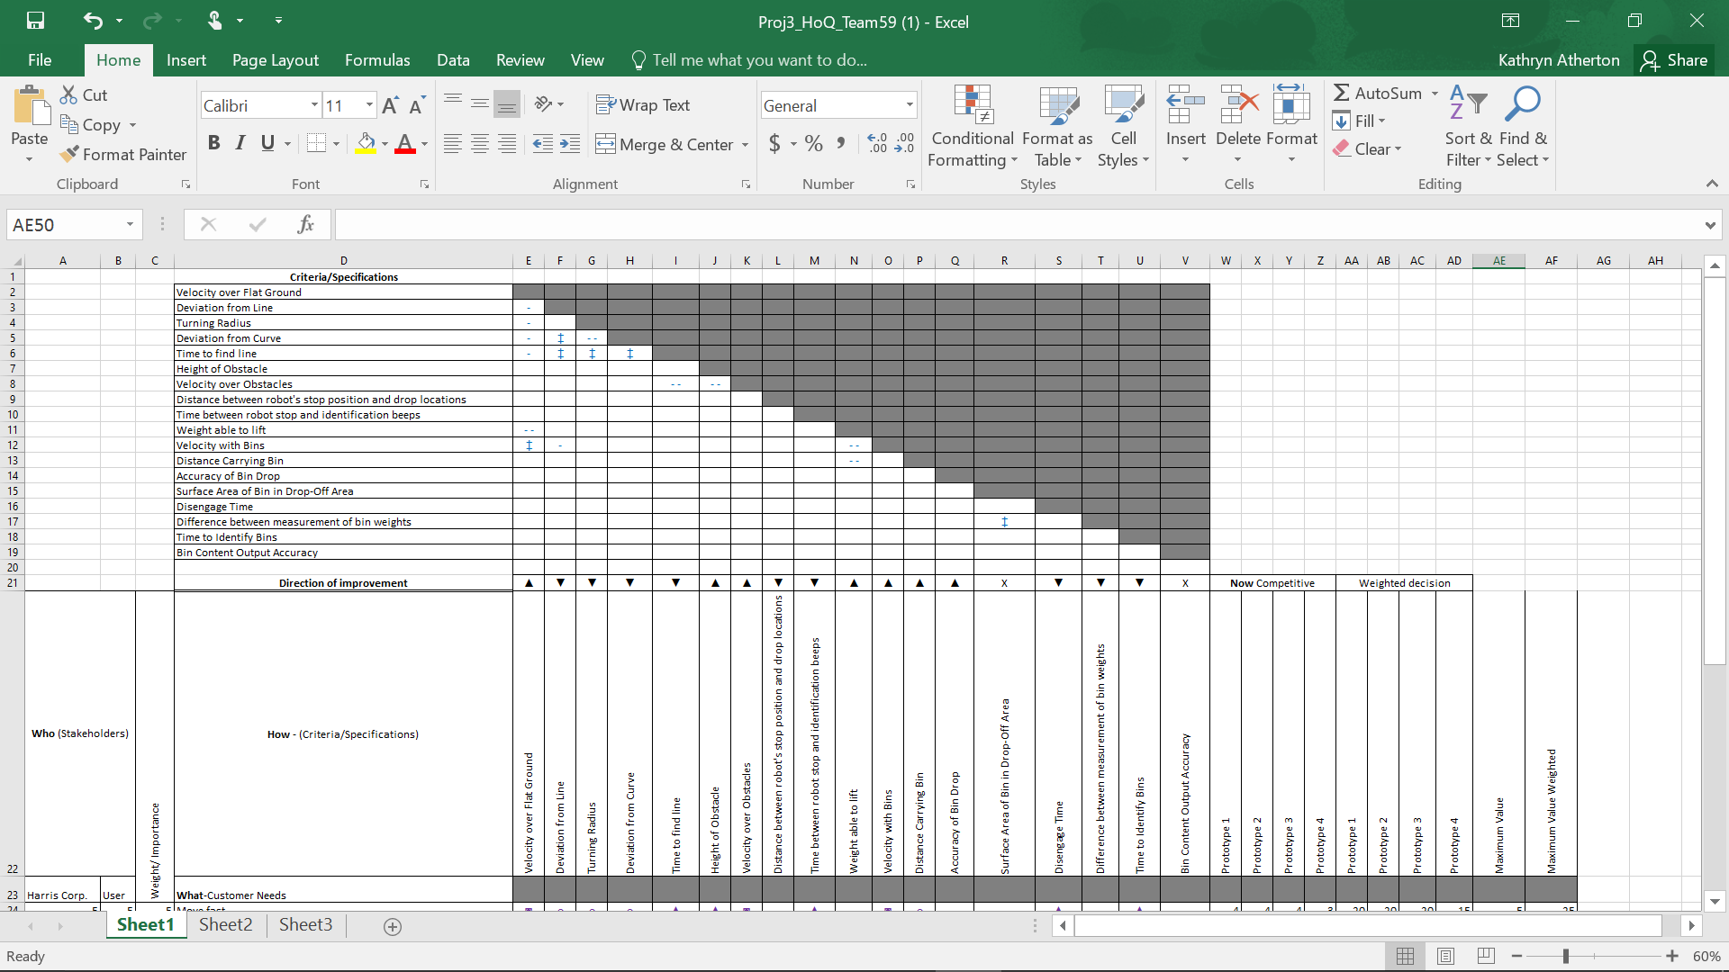

**Table 15: Bin Drop-Off Specification Metrics for Prototype 4**

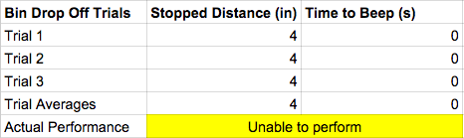

**Table 16: Bin pick-up trials Metrics for Prototype**

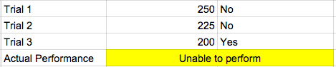

**Table 17: Bin Movement Trials for Prototype**

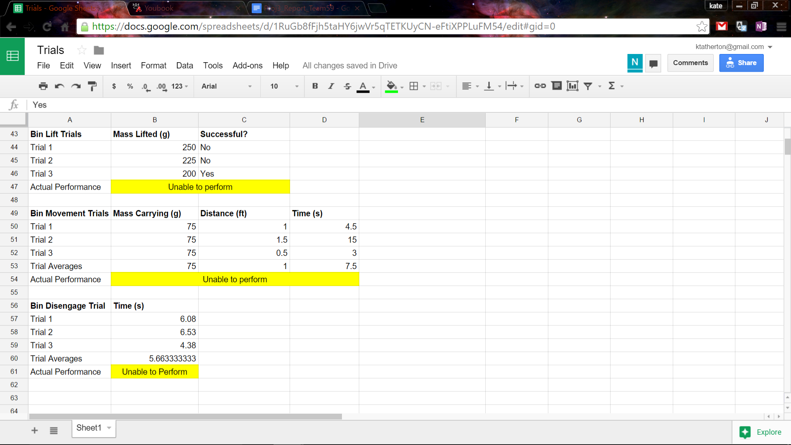

**Table 18: Bin Disengage Trials for Prototype**



**Table 19: Walking Trials for Prototype**

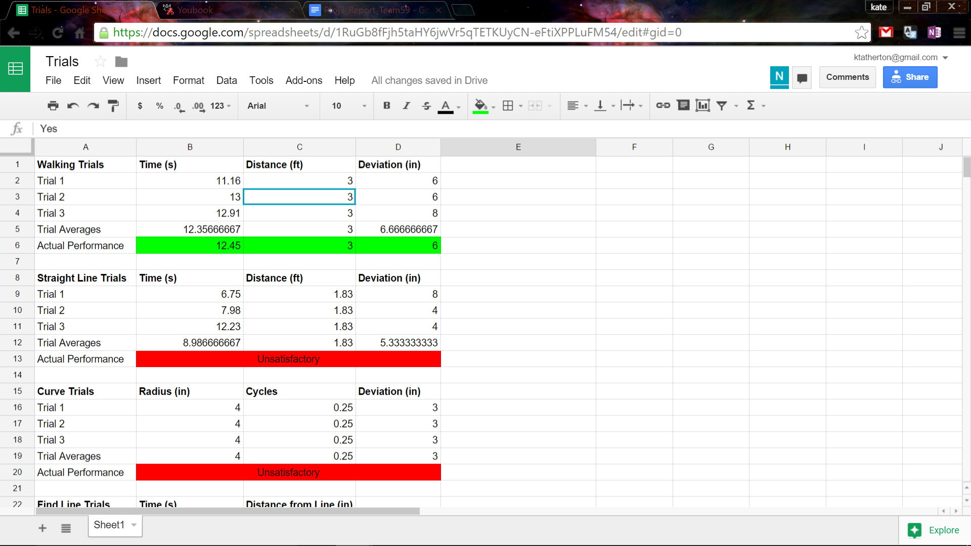

**Table 20: Straight Line Follow Trials for Prototype**



**Table 21: Curve Line Follow Trials for Prototype**



**Table 22: Find Line Trials for Prototype**

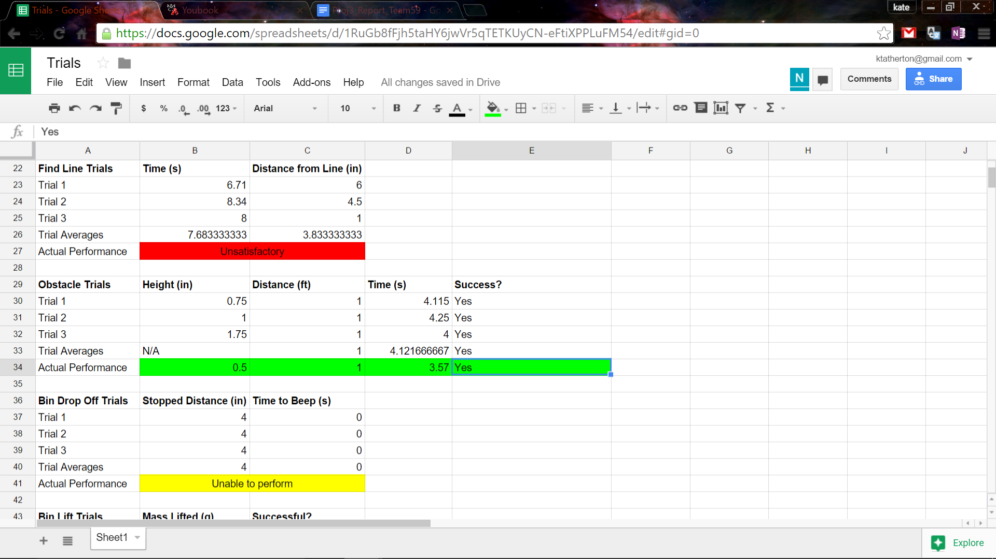

**Table 23: Obstacle Trials for Prototype**

